**ASSIGNMENT – 5(1)**

**ON: RESTRICTING AND SORTING DATA**

**Q1. Show the structure of the EMPLOYEES table. Create a query to display the last name, job code, hire date and employee number for each employee, with employee number appearing first.**

Ans1.

DESCRIBE EMPLOYEES;

SELECT EMPLOYEE_ID, LAST_NAME, JOB_ID, HIRE_DATE

FROM EMPLOYEES;

**Verification table 1 -**

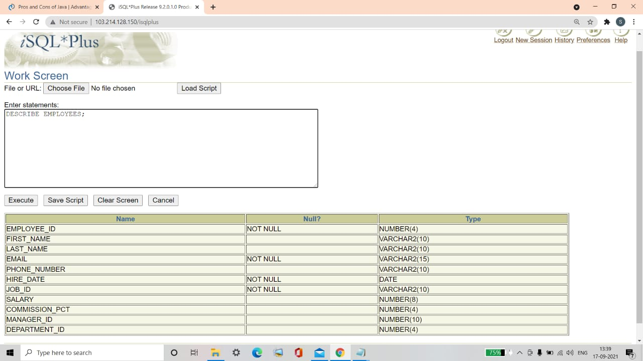

**Verification table 2-**

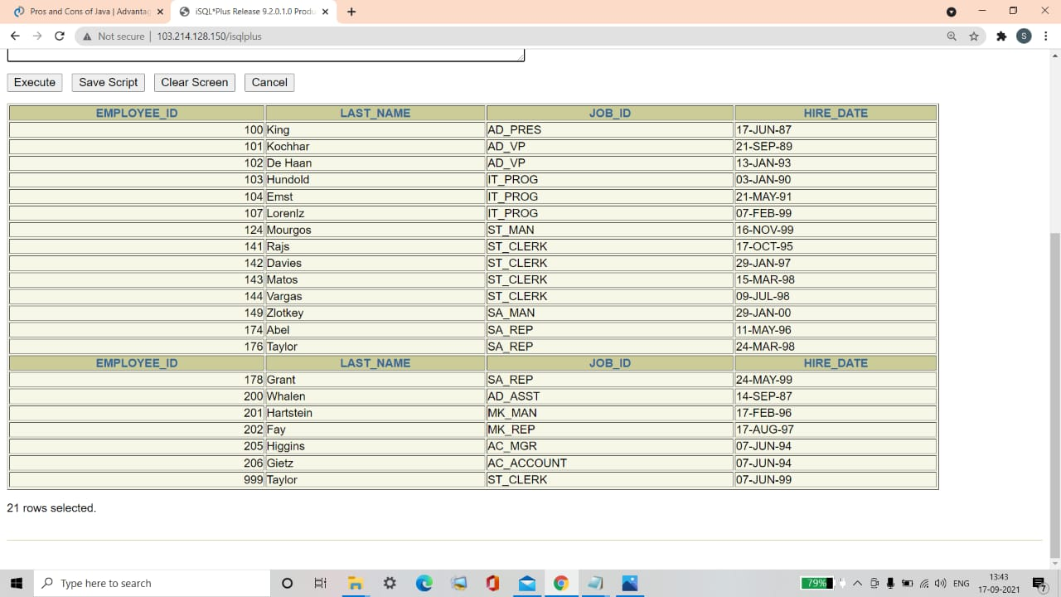

**Q2. Create a query to display unique job codes from the EMPLOYEES table.**

Ans2.

SELECT DISTINCT JOB_ID

FROM EMPLOYEES;

**Verification table -**

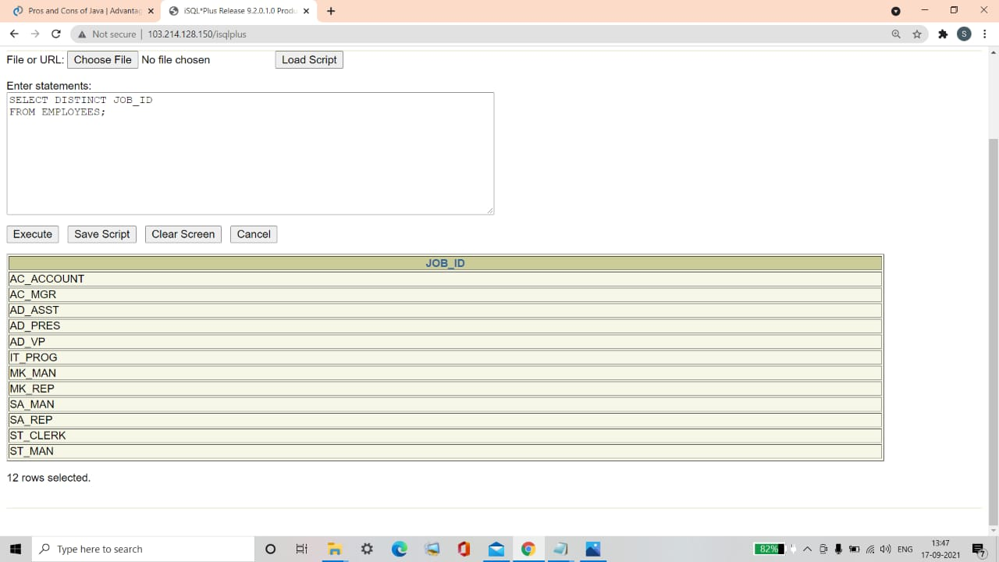

**Q3. Create a query to display the column headings in EMPLOYEES table as. Emp #, Employee, Job, and Hire Date, respectively.**

Ans3.

SELECT EMPLOYEE_ID "Emp#", LAST_NAME "Employee",

JOB_ID "Job", HIRE_DATE "Hire Date"

FROM EMPLOYEES;

**Verification table -**

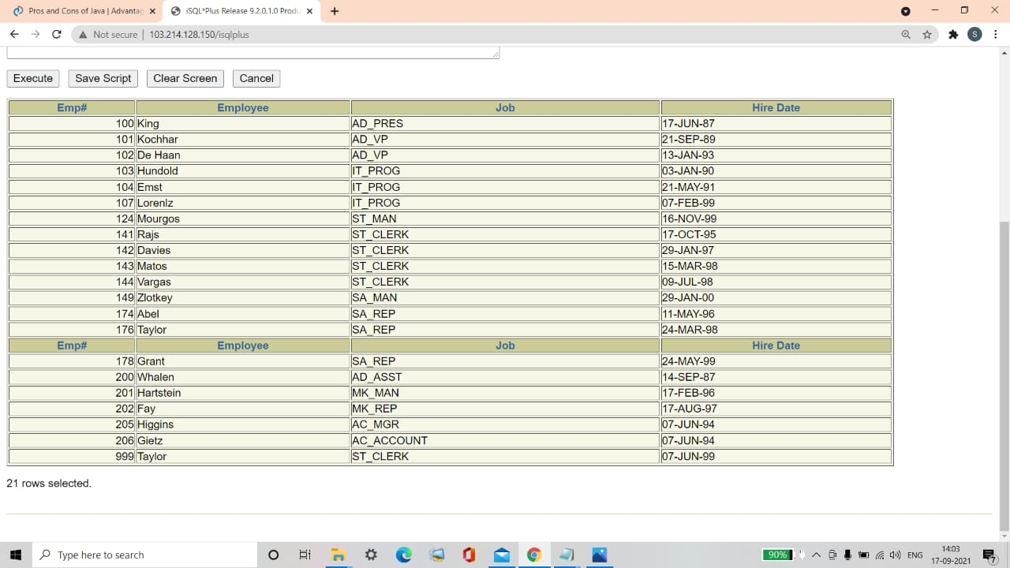

**Q4. Display the last name concatenated with the job ID, separated by a comma and space, and name the column Employee and Title.**

|  |
| --- |
| **Employee and Title** |
| **King, AD_PRES** |
| **Kochhar, AD_VP** |
| **De Haan, AD_VP** |
| **Hunold, IT_PROG** |
| **Ernst, IT_PROG** |
| **Lorentz, IT_PROG** |
| **Mourgos, ST_MAN** |
| **Rajs, ST_CLERK** |
| **Davies, ST_CLERK** |

Ans4**.**

SELECT LAST_NAME||', '||JOB_ID "Employee and Title"

FROM EMPLOYEES;

**Verification table -**

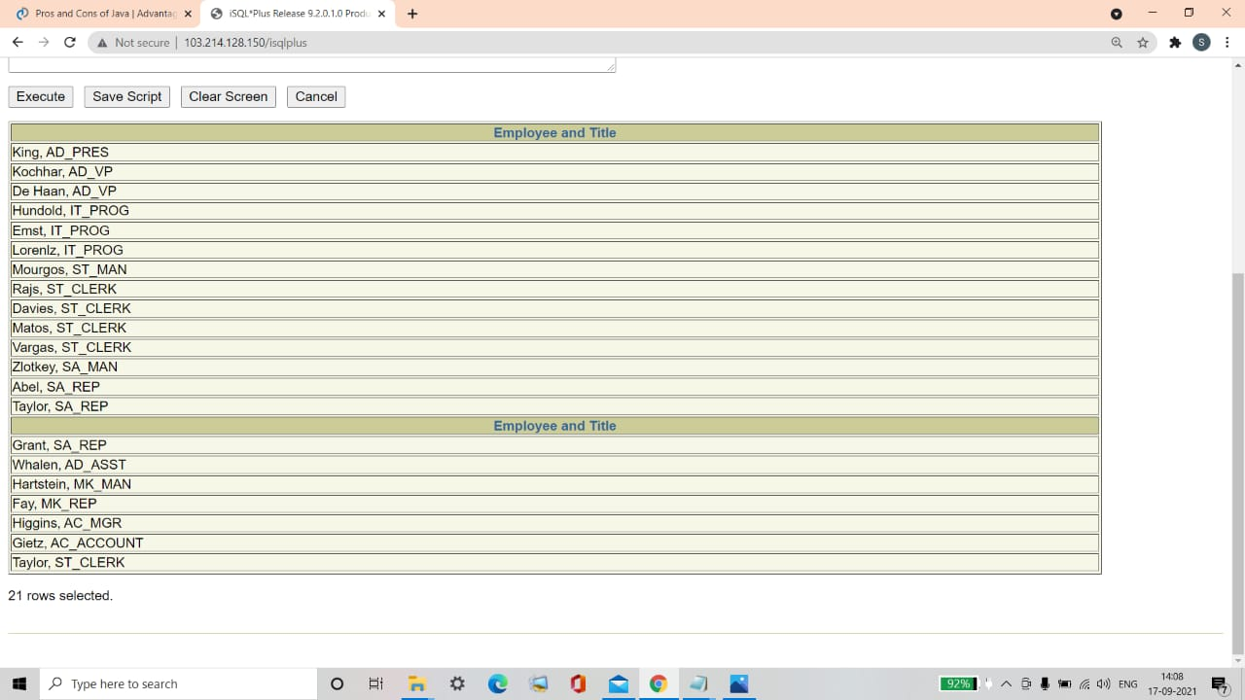

**Q5. Create a query to display all the data from the EMPLOYEES table. Separate each column by a comma. Name the column THE_OUTPUT.**

|  |
| --- |
| **THE_OUTPUT** |
| **100,Steven,King,SKING,515.123.4567,AD_PRES,,17-JUN-87,24000,,90** |
| **101,Neena,Kochhar,NKOCHHAR,515.123.4568,AD_VP,100,21-SEP-89,17000,,90** |
| **102,Lex,De Haan,LDEHAAN,515.123.4568,AD_VP,100,13-JAN-93,17000,,90** |
| **103,Alexander,Hunold,AHUNOLD,590.423.4567,IT_PROG,102,03-JAN-90,9000,,60** |
| **104,Bruce,Ernst,BERNST,590.423.4568,IT_PROG,103,21-MAY-91,6000,,60** |
| **107,Diana,Lorentz,DLORENTZ,590.423.5567,IT_PROG,103,07-FEB-99,4200,,60** |
| **124,Kevin,Mourgos,KMOURGOS,650.123.5234,ST_MAN,100,16-NOV-99,5800,,50** |
| **141,Trenna,Rajs,TRAJS,650.121,8009,ST_CLERK,124,17-OCT-95,3500,,50** |

Ans5**.**

SELECT EMPLOYEE_ID||','||FIRST_NAME||','||LAST_NAME

||','||EMAIL||','||PHONE_NUMBER||','||HIRE_DATE

||','||JOB_ID||','||SALARY||','||COMMISSION_PCT

||','||MANAGER_ID||','||DEPARTMENT_ID "THE_OUTPUT"

FROM EMPLOYEES;

**Verification table–**

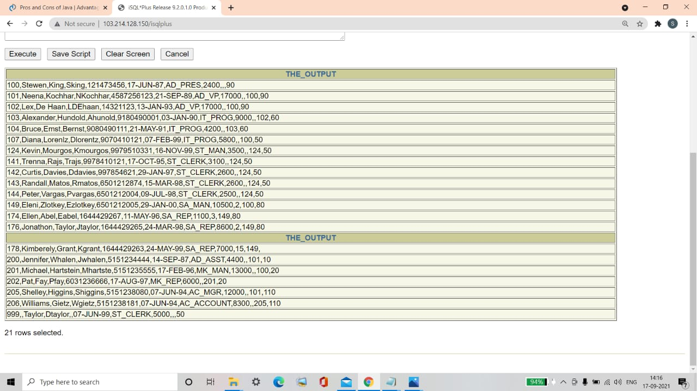

**ASSIGNMENT – 5(2)**

**ON: RESTRICTING AND SORTING DATA**

**Q1. Create a query to display the last name and salary of employees earning more than $12,000. Place your SQL statement in a text file named lab5_1.sql. Run your query.**

|  |  |
| --- | --- |
| **LAST_NAME** | **SALARY** |
| **King** | **24000** |
| **Kochhar** | **17000** |
| **De Haan** | **17000** |
| **Hartstein** | **13000** |

Ans1.

SELECT LAST_NAME, SALARY

FROM EMPLOYEES

WHERE SALARY >12000;

**Verification table -**

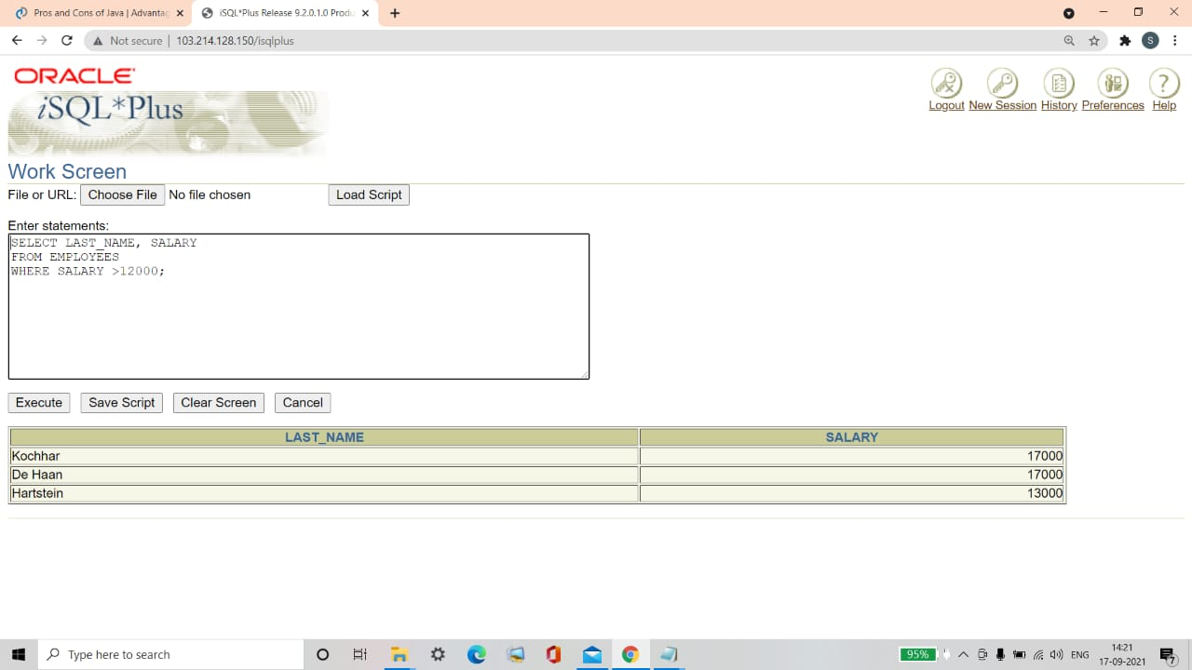

**Q2. Create a query to display the employee last name and department number for each employee number 176.**

|  |  |
| --- | --- |
| **LAST_NAME** | **DEPARTMENT_ID** |
| **Taylor** | **80** |

Ans2**.**

SELECT LAST_NAME, DEPARTMENT_ID

FROM EMPLOYEES

WHERE EMPLOYEE_ID=176;

**Verification table -**

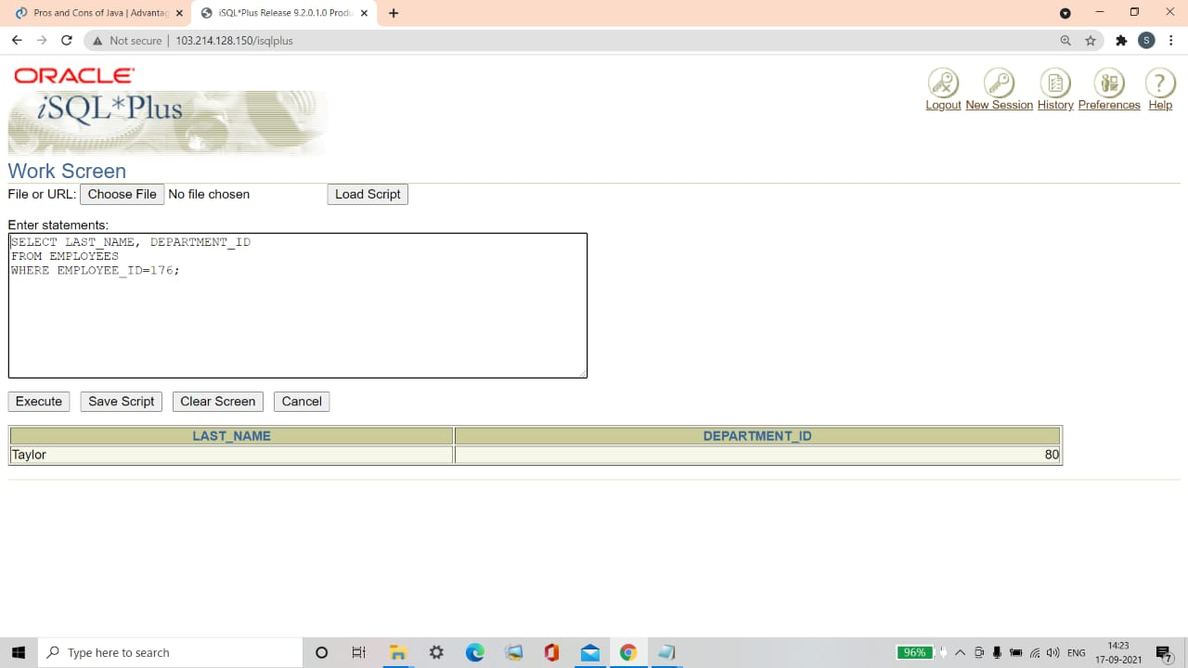

**Q3. Modify lab5_1.sql to display the last name and salary for all employees whose salary is not in the range of $5,000 and $12,000. Place your SQL statement in a text file named lab5_3.sql.**

|  |  |
| --- | --- |
| **LAST_NAME** | **SALARY** |
| **King** | **24000** |
| **Kochhar** | **17000** |
| **De Haan** | **17000** |
| **Lorentz** | **4200** |
| **Rajs** | **3500** |
| **Davies** | **3100** |
| **Matos** | **2600** |
| **Vargas** | **2500** |
| **Whalen** | **4400** |
| **Hartstein** | **13000** |

**10 rows selected.**

Ans3**.**

SELECT LAST_NAME, SALARY

FROM EMPLOYEES

WHERE SALARY NOT BETWEEN 5000 AND 12000;

**Verification table -**

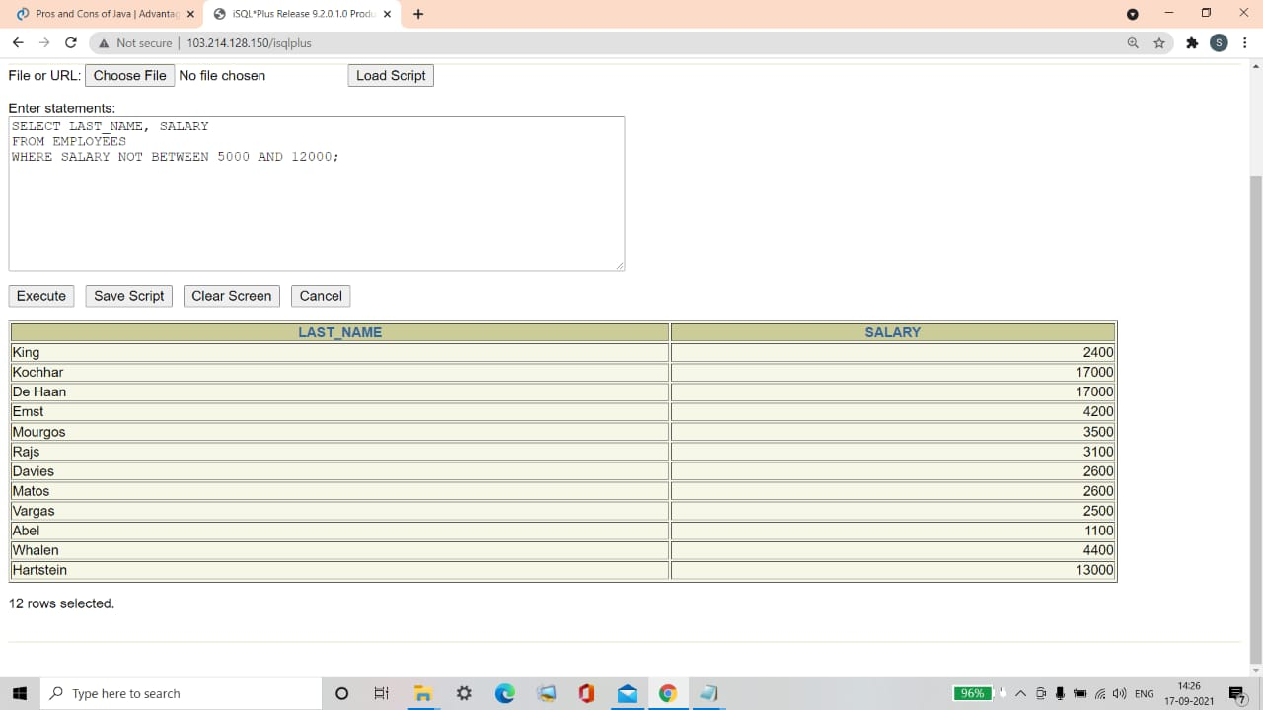

**Q4. Display the employee last name, job ID, and start date of employees hired between February 20, 1998 and May 1, 1998. Order the query in ascending order by start date.**

|  |  |  |
| --- | --- | --- |
| **LAST_NAME** | **JOB_ID** | **HIRE_DATE** |
| **Matos** | **ST_CLERK** | **15-MAR-98** |
| **Taylor** | **SA_REP** | **24_MAR-98** |

Ans4.

SELECT LAST_NAME,JOB_ID,HIRE_DATE

FROM EMPLOYEES

WHERE HIRE_DATE BETWEEN '20-Feb-1998' AND '01-MAY-1998'

ORDER BY HIRE_DATE ASC;

**Verification table -**

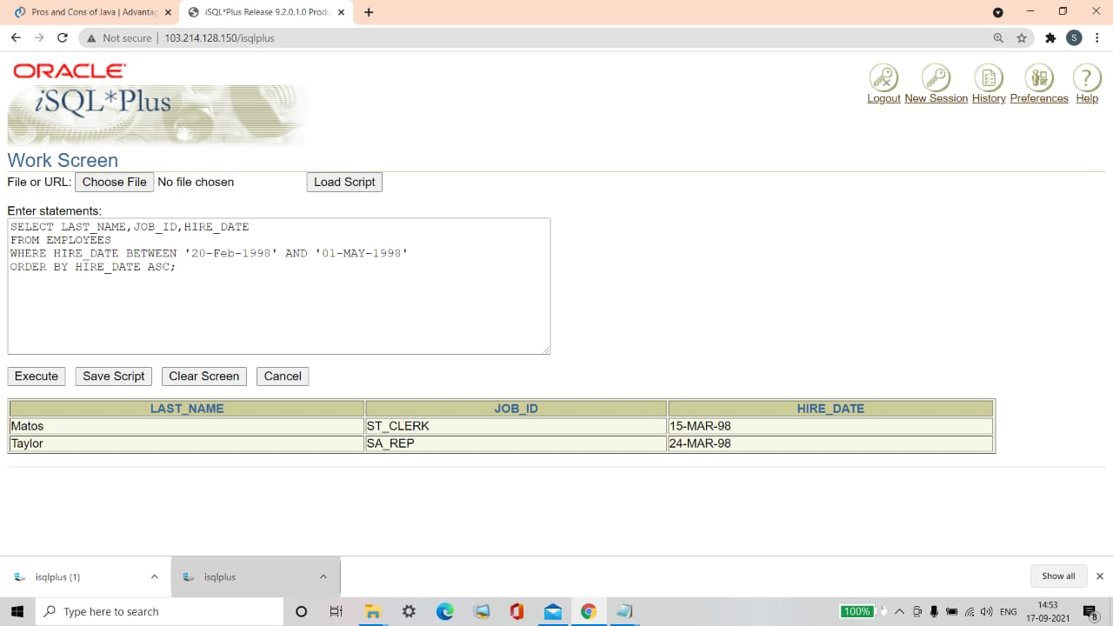

**Q5. Display the last name and department number of all employees in departments 20 and 50 in alphabetical order by name.**

|  |  |
| --- | --- |
| **LAST_NAME** | **DEPARTMENT_ID** |
| **Davies** | **50** |
| **Fay** | **20** |
| **Hartstein** | **20** |
| **Matos** | **50** |
| **Mourgos** | **50** |
| **Rajs** | **50** |
| **Vargas** | **50** |

**7 rows selected.**

Ans5.

SELECT LAST_NAME,DEPARTMENT_ID

FROM EMPLOYEES

WHERE DEPARTMENT_ID IN (20,50)

ORDER BY LAST_NAME ASC;

**Verification table -**

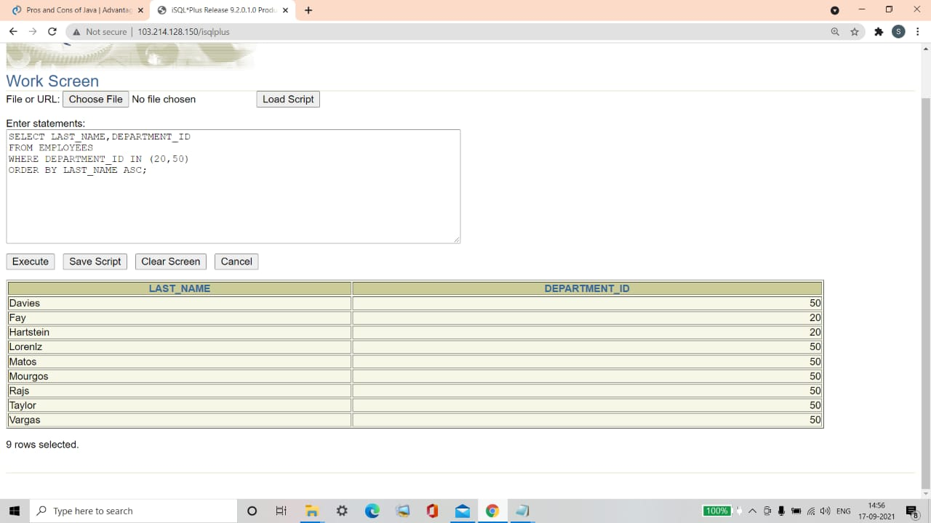

**Q6. Modify lab5_3.sql to list the last name and salary of employees who earn between $5,000 and $12000, and are in department 20 or 50. Label the columns Employee and Monthly Salary, respectively. Resave lab5_3.sql as lab5_6.sql. Run the statement in lab5_6.sql.**

|  |  |
| --- | --- |
| **Employee** | **Monthly Salary** |
| **Mourgos** | **5800** |
| **Fay** | **6000** |

Ans6.

SELECT LAST_NAME "Employee", SALARY "Monthly Salary"

FROM EMPLOYEES

WHERE SALARY BETWEEN 5000 AND 12000

AND DEPARTMENT_ID IN (20,50);

**Verification table–**

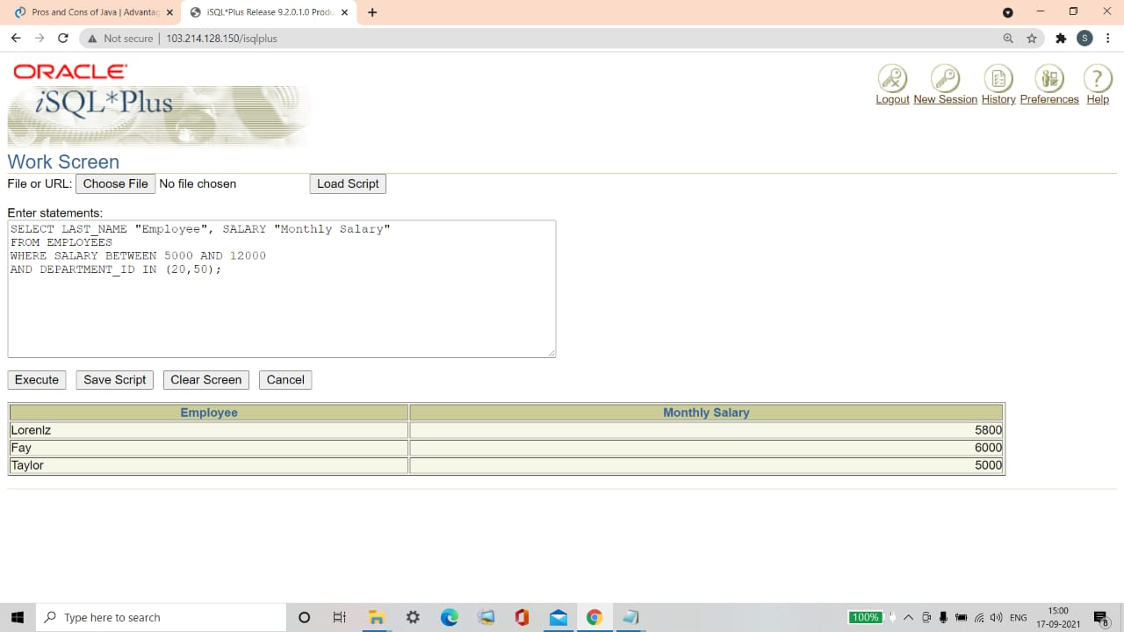

**Q7. Display the last name and hire date of every employee who was hired in 1994.**

|  |  |
| --- | --- |
| **LAST_NAME** | **HIRE_DATE** |
| **Higgins** | **07-JUN-94** |
| **Gietz** | **07-JUN-94** |

Ans7.

SELECT LAST_NAME, HIRE_DATE

FROM EMPLOYEES

WHERE HIRE_DATE LIKE '%94';

**Verification table -**

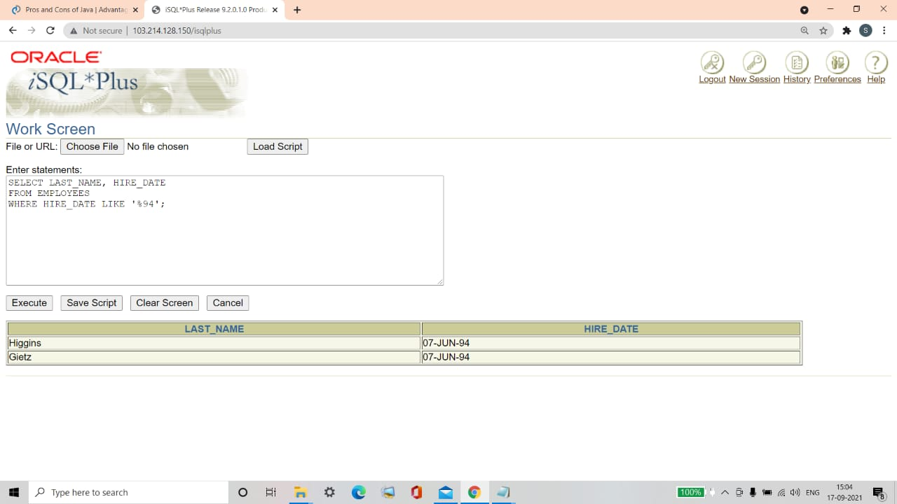

**Q8. Display the last name and job title of all employees who do not have a manager.**

|  |  |
| --- | --- |
| **LAST_NAME** | **JOB_ID** |
| **King** | **AD_PRES** |

Ans8**.**

SELECT LAST_NAME, JOB_ID

FROM EMPLOYEES

WHERE MANAGER_ID IS NULL;

**Verification table -**

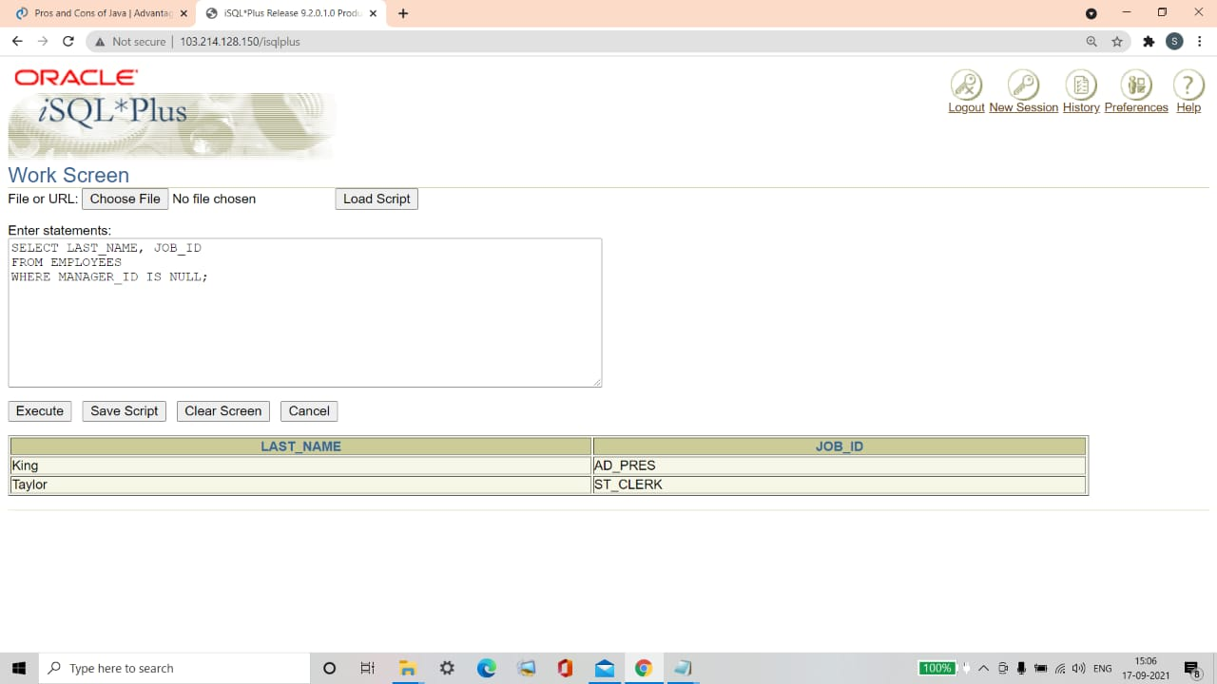

**Q9. Display the last name, salary and commission for all employees who earn commissions. Sort data in descending order of salary and commissions.**

|  |  |  |
| --- | --- | --- |
| **LAST_NAME** | **SALARY** | **COMMISSION _PCT** |
| **Abel** | **11000** | **.3** |
| **Zlotkey** | **10500** | **.2** |
| **Taylor** | **8600** | **.2** |
| **Grant** | **7000** | **.15** |

Ans9.

SELECT LAST_NAME, SALARY, COMMISSION_PCT

FROM EMPLOYEES

WHERE COMMISSION_PCT IS NOT NULL

ORDER BY SALARY DESC, COMMISSION_PCT DESC;

**Verification table -**

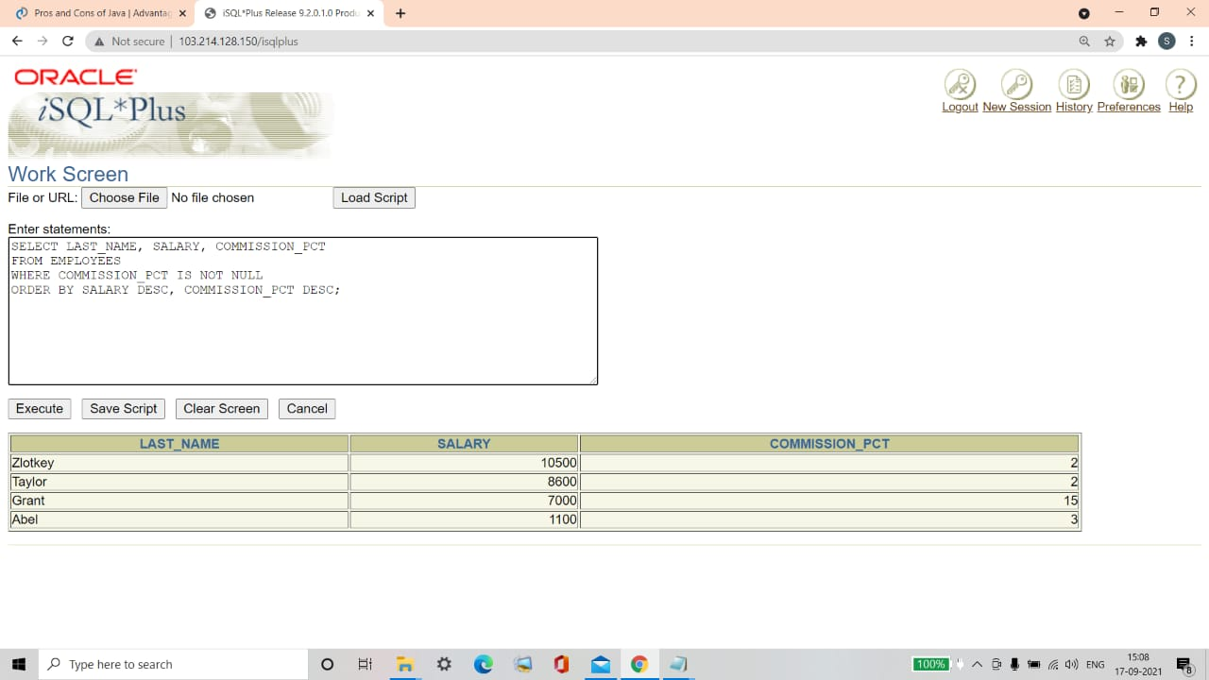

**Q10. Display the last names of all employees where the third letter of the name is an a.**

|  |
| --- |
| **LAST_NAME** |
| **Grant** |
| **Whalen** |

Ans10.

SELECT LAST_NAME

FROM EMPLOYEES

WHERE LAST_NAME LIKE '__a%';

**Verification table -**

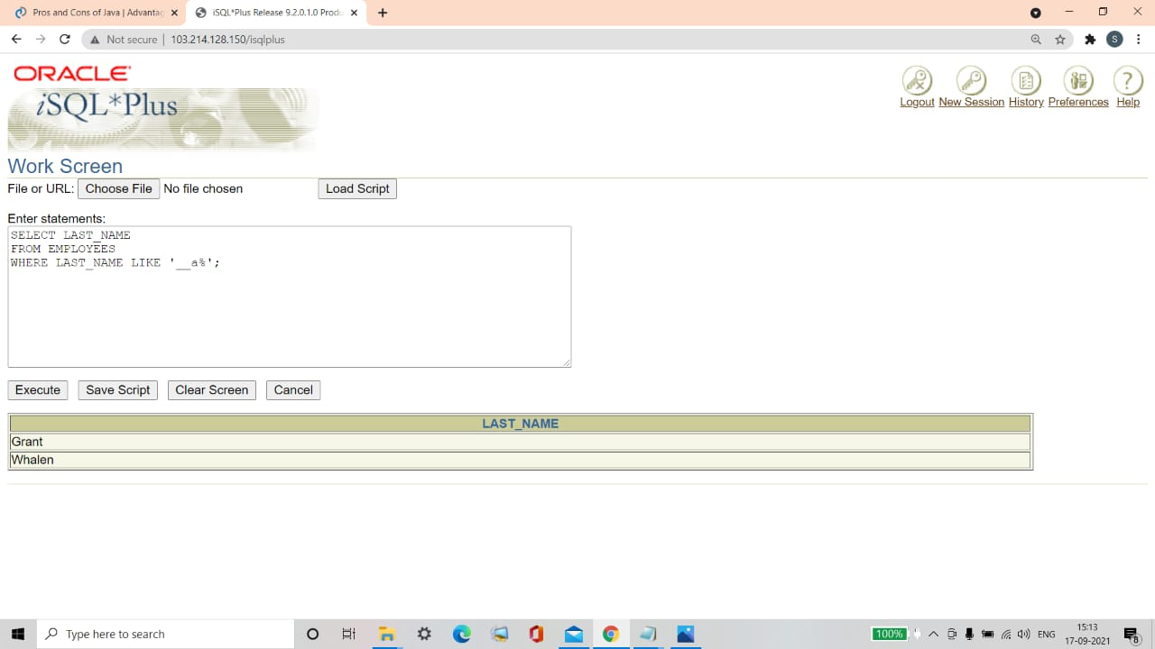

**Q11. Display the last names of all employees who have ana and an e in their last name.**

|  |
| --- |
| **LAST_NAME** |
| **De Haan** |
| **Davies** |
| **Whalen** |
| **Hartstein** |

Ans11.

SELECT LAST_NAME

FROM EMPLOYEES

WHERE LAST_NAME LIKE '%a%' AND LAST_NAME LIKE '%e%';

**Verification table -**

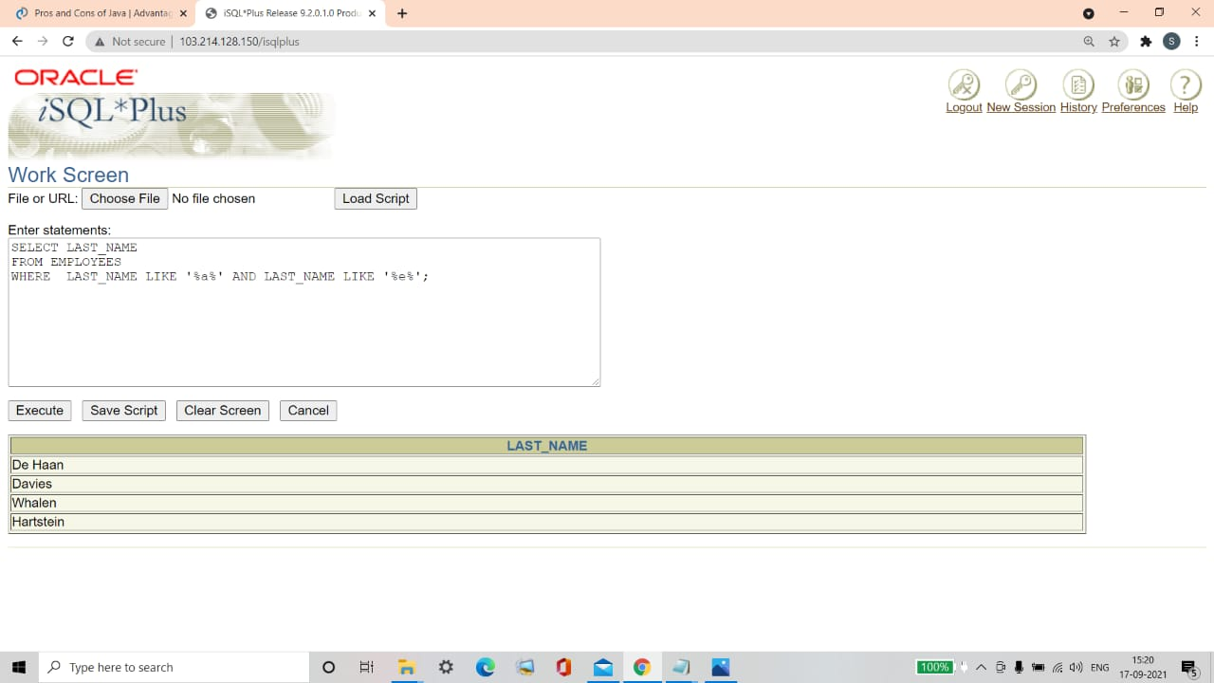

**Q12. Display the last name, job, and salary for all employees whose job is sales representative or stock clerk and whose salary is not equal to $2,500, $3,500, or $7,000.**

|  |  |  |
| --- | --- | --- |
| **LAST_NAME** | **JOB_ID** | **SALARY** |
| **Davies** | **ST_CLERK** | **3100** |
| **Matos** | **ST_CLERK** | **2600** |
| **Abel** | **SA_REP** | **11000** |
| **Taylor** | **SA_REP** | **8600** |

Ans12.

SELECT LAST_NAME, JOB_ID, SALARY

FROM EMPLOYEES

WHERE JOB_ID='SA_REP' OR JOB_ID='ST_CLERK'

AND SALARY NOT IN (2500,3500,7000);

**Verification table -**

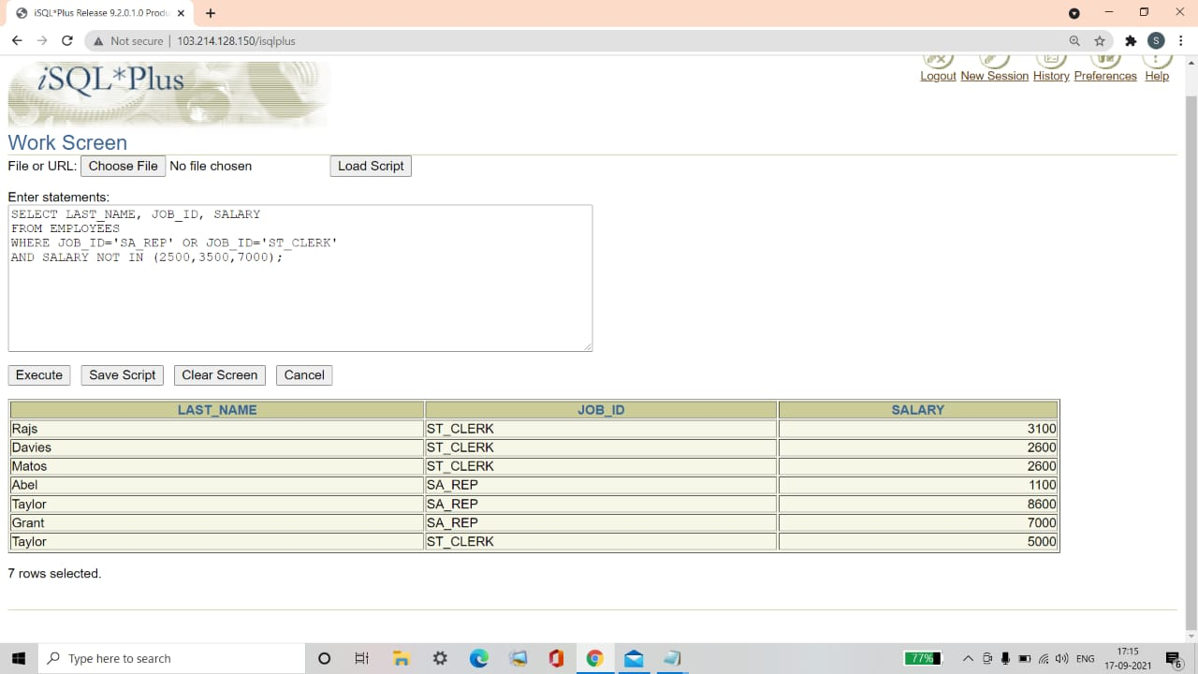

**Q13. Modify lab5_6.sql to display the last name, salary, and commission for all employees whose commission amount is 200%. Resave lab5_6.sql as lab5_13.sql. Rerun the statement in lab5_13.sql.**

|  |  |  |
| --- | --- | --- |
| **Employee** | **Monthly Salary** | **COMMISSION_PCT** |
| **Zlotkey** | **10500** | **2** |
| **Taylor** | **8600** | **2** |

Ans13.

SELECT LAST_NAME "Employee", SALARY "Monthly Salary", COMMISSION_PCT

FROM EMPLOYEES

WHERE COMMISSION_PCT=2;

**Verification table–**

